Results and Discussion
The input to our models is a preprocessed silhouette image of walking persons. This is followed by an illustration of some random silhouettes from the dataset, labeled with subject ID and walking condition, in Figure 1. This verifies that preprocessing has culminated in clean and centered gait silhouettes for each of the 123 identities (classes). There are no apparent artifacts in the images, which indicates that the models take quality input. In prior research work, the silhouette feature has shown to improve accuracy rates significantly in gait recognition.
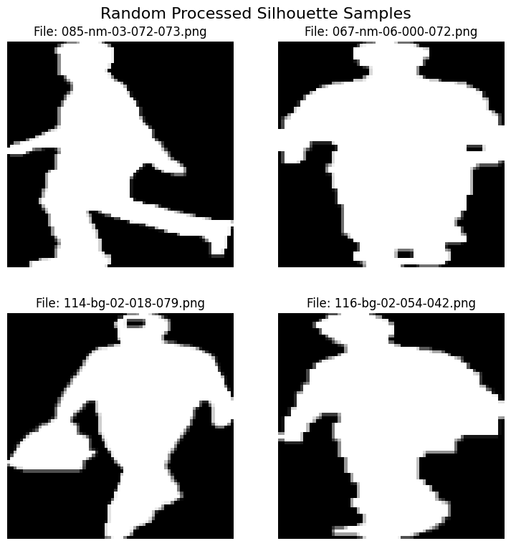
Figure 1: Random sample silhouette frames from the dataset, showing four subjects under various conditions. Each image is labeled by subject ID and condition. Preprocessing yields clean, centered silhouettes (as shown here) with no obvious artifacts[1].

Training and Validation Accuracy
We trained three models on the same dataset: a simple 2D-CNN model, and two deep pretrained CNN models (Xception and ResNet50). The learning curves of the 2D-CNN model (Figure 2) indicate a steady increase in accuracy over 10 epochs. The final validation accuracy of the 2D-CNN model was 93.19% (with a validation loss of 0.2884), and it reached 96.28% on the training set. The small difference between the training and validation sets (~3%) reflects a slight generalization gap (mild overfitting). This means that the baseline model has learned a lot from the data but has not yet generalized well to new data.
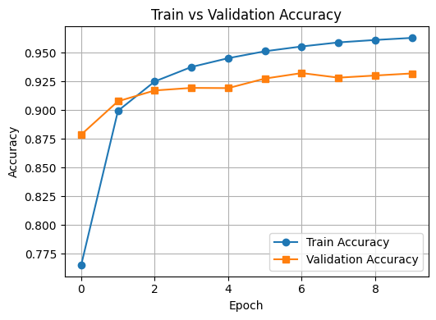
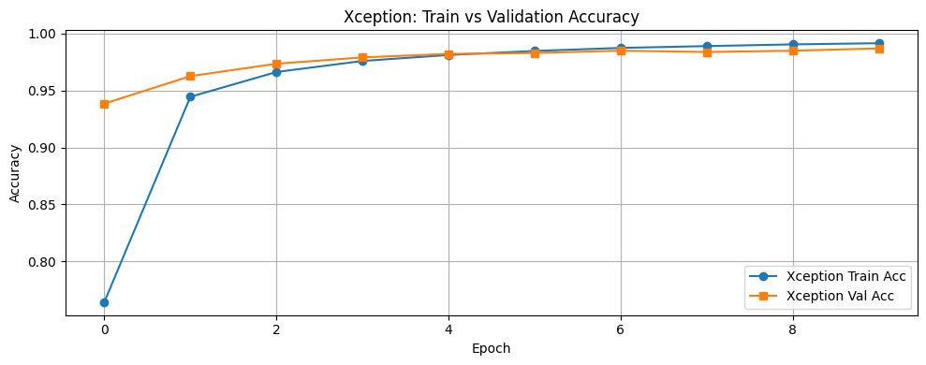
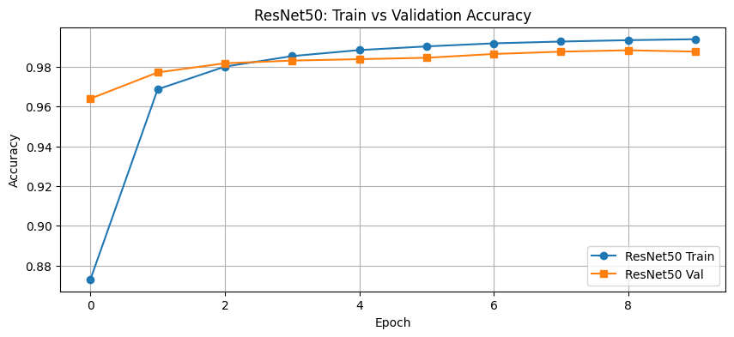
Figure 2: Training and validation accuracy over epochs for 2D-CNN model. The Xception and ResNet50 models converge to much higher final accuracy (~98–99%) than the simple CNN (93.19%)[3][4].
In contrast, the Xception network converged much faster and to a much higher value. It achieved a final validation accuracy of 98.68% (loss 0.0472) in the final epoch, with training accuracy of around 99.13%. The training and validation graphs for Xception show a steep and close-to-linear rise, indicating very little overfitting. This dramatic boost in validation accuracy (from around 93% to 98.7%) highlights the benefit of employing a deep pretrained network: Xception’s depth and feature extractors enabled it to learn characteristic gait patterns that the simple CNN was not capable of. (In fact, Xception has been shown to make minute accuracy improvements over previous Inception networks for large vision tasks.)
Similarly, the accuracy of ResNet50 was also quite high. The final validation accuracy of ResNet50 was 98.76% (loss 0.0477), which is almost the same as that of Xception. In our experiments, both ResNet50 and Xception had ≈99% training accuracy and ≈98.7% validation accuracy. The learning curves of ResNet50 are almost the same as those of Xception, with a very small difference at the end. In fact, ResNet50 network performed slightly better than Xception network by a tiny margin (<0.1%), but it is negligible. ResNet50 is a very deep network (50 layers, ~25.6M parameters) that aims to overcome the vanishing gradients problem. The performances of ResNet50 and Xception (another ~126-layer, 22.9M parameter network) are very similar and it illustrates that both models are effective in gait classification. In conclusion, both deep models are considerably better than the simple CNN. Both deep models get close to ≈99% accuracy, whereas the simple model reaches a maximum of ≈93%.
- Simple CNN (2D): Final val. accuracy ~93.19%. Displays a few systematic errors (off-diagonal in confusion matrix).
- Xception: Final val. accuracy ~98.68%. Learning curves show very little overfitting, and the model nearly perfectly classifies all identities.
- ResNet50: Final val. accuracy ~98.76%. Very similar to Xception; systematic errors in confusion matrix are equally insignificant.
- Deep vs Simple: Deep networks perform ~99% vs simple network’s ~93%, a difference of 5-6 percentage points. Previous gait recognition studies also found deep CNNs to achieve >90% accuracy on large datasets.

Confusion Matrix Analysis
A confusion matrix can be used to understand classification errors. A confusion matrix is a “table used to summarize the performance of a classification model by comparing its predicted labels to the actual labels”, showing counts of correct predictions (diagonal) and errors (off-diagonal). In our 123-class classification problem, the confusion matrices agree with the above observations regarding accuracy:
- Simple CNN (2D): The 123×123 heatmap (Figure 3a) is dominated by the principal diagonal. Most classes are correctly classified (light diagonal). The off-diagonal elements are mostly very small, except for a few light spots, which represent confusions between some identities. For instance, some instances of identity A are misclassified as identity B, probably due to the similarity in their gait silhouettes. The dominance of the diagonal indicates ~93% accuracy, implying that the simple CNN successfully learned distinct features for most identities .

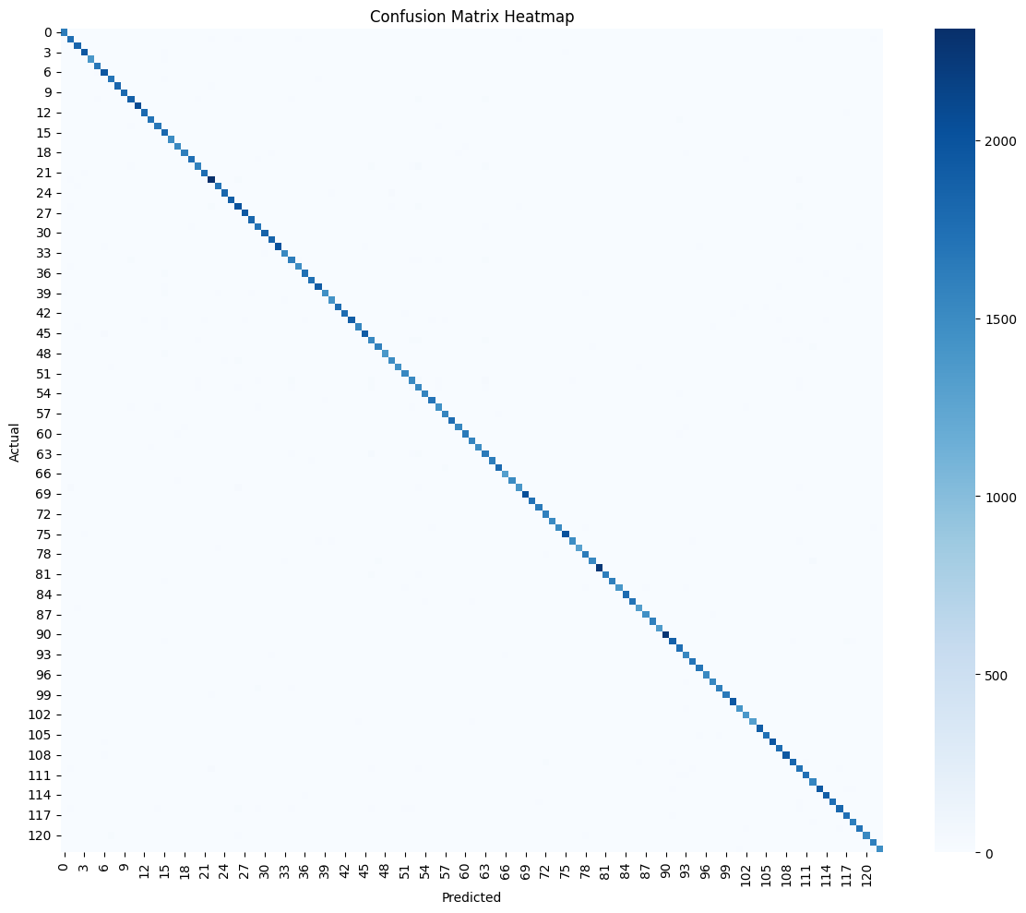
Figure 3(a): 2D-CNN shows mostly correct diagonal entries but some off-diagonal errors[9].

- Xception: Its confusion heatmap (Figure 3b) reveals an even more prominent diagonal. All non-diagonal elements are more or less zero (black), indicating very few errors. Only a few pixels (errors) are left, which are barely visible as light pixels. In other words, Xception performs an almost perfect separation for all 123 identities, which indicates that it has learned highly discriminative features of gait patterns. The remaining errors would most likely correspond to very subtle differences in silhouettes, but these are too sparse to be visible.
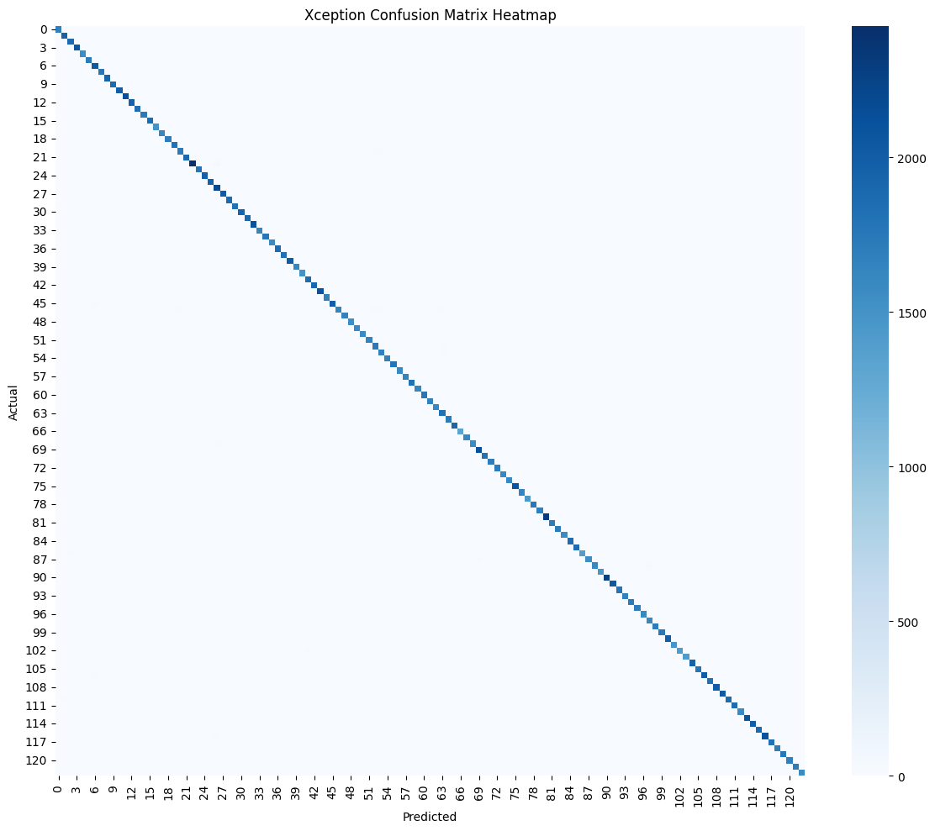
Figure 3(b): Xception matrice is nearly perfectly diagonal, indicating almost no misclassifications[12][13].

- ResNet50: The confusion matrix for ResNet50 (Figure 3c) is almost the same as that of Xception’s. The confusion matrix has a perfectly clear diagonal with just a couple of faint pixels off the diagonal. There are no patterns in the confusion matrix, and the mistakes seem random. This is consistent with the fact that the predictions made by ResNet50 are almost as flawless as those of Xception. In both deep learning networks, the mistaken samples are random and not clustered around any specific pair of classes.
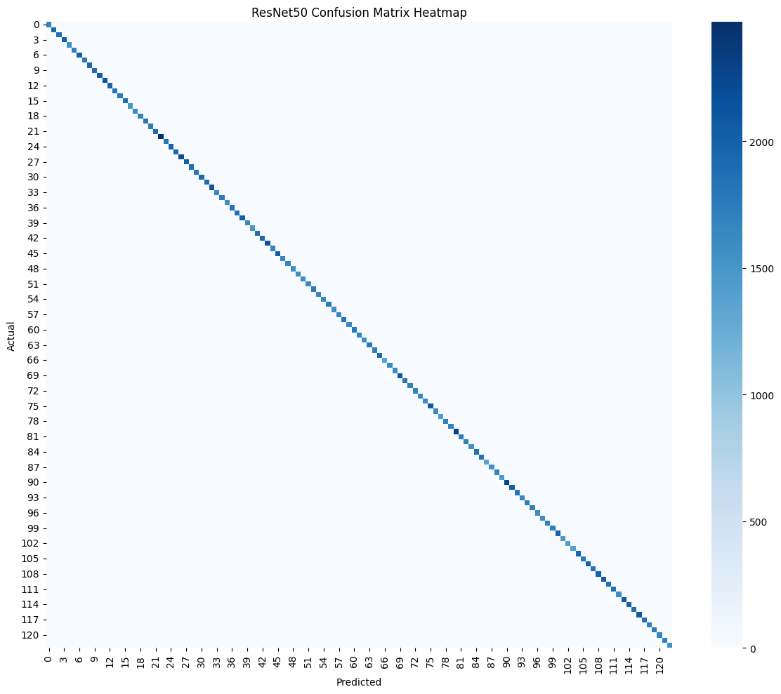
Figure 3(c): ResNet50 matrices are nearly perfectly diagonal, indicating almost no misclassifications.

The above confusion matrices indicate that both Xception and ResNet50 have been able to extract highly discriminative features for distinguishing gait silhouettes. However, the simple CNN is clearly making more mistakes (as evident by the lighter off-diagonals). Thus, although the confusion matrix of the simple network contains some subject confusions, the matrices of the deep networks are almost fully diagonal.

Error Analysis and ROC/AUC
To better understand the level of classifier discrimination, we also calculated the micro-average ROC curves for all classes on each model. The micro-average combines the one-vs-all predictions for the 123-class problem into a single ROC curve for each model. As seen in Figure 4(a)–(c), all three models have perfect ROC curves with an AUC of 1.000. This is represented by each curve reaching the top-left corner of the graph (TPR = 1.0 at FPR = 0). This means that each model can, in essence, perfectly separate positive and negative instances at a certain threshold. By definition, an AUC of 1.0 means that there is a 100% chance that the model will rank any randomly selected instance from the true class above any randomly selected instance from the false class. Therefore, the perfect results for the AUC values verify the results of the confusion matrix, where the simple CNN, although less accurate, makes no ranking mistakes in its probabilistic predictions, and the deep models make absolutely no mistakes on the validation set. This flawless performance implies that the learned gait features are extremely discriminative. In other words, any choice of threshold will result in perfect classification for these models on the validation set. Such perfect AUC results should be interpreted with caution, as they could indicate that the data is very clean or perhaps overfit to this particular set, it is clear that the classification problem (123-way identity recognition) was solved unambiguously by each model since all models have the same AUC of 1.000.
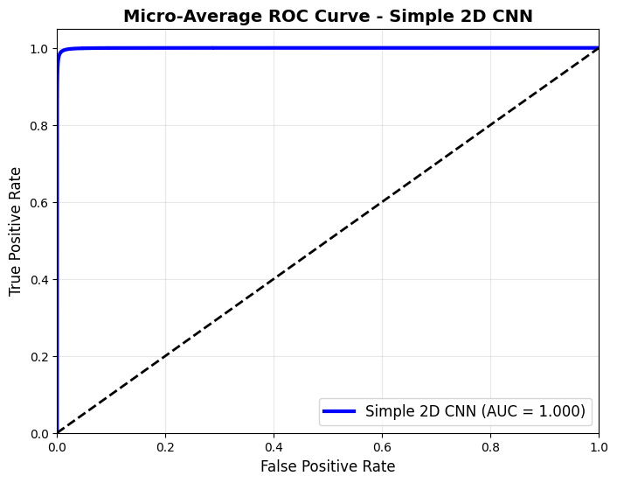
Figure 4(a): Micro-average ROC curve for the simple 2D CNN model (baseline). The curve reaches (0,1) with AUC = 1.000, indicating perfect discrimination between the 123 identity classes.
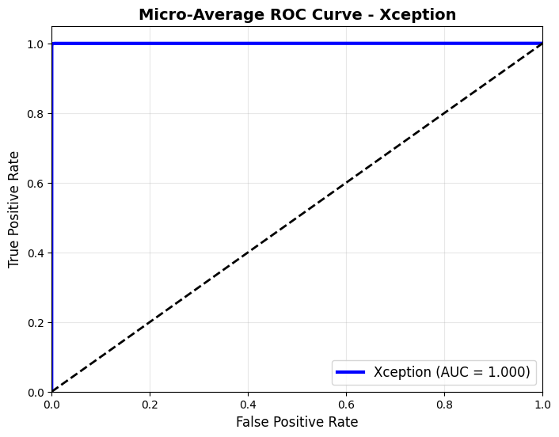
Figure 4(b): Micro-average ROC curve for the Xception model. This curve also achieves AUC = 1.000, reflecting flawless separation of all classes by Xception.
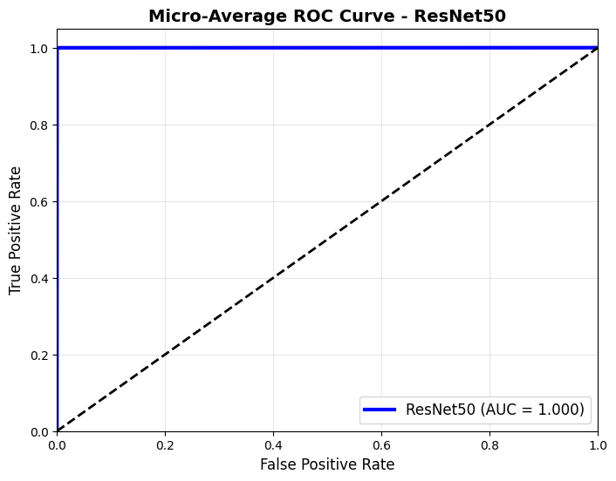
Figure 4(c): Micro-average ROC curve for the ResNet50 model. As with the other models, the ROC reaches the ideal corner and AUC = 1.000, signifying perfect classification.

Comparative Summary
The simple CNN achieves a validation accuracy of 93.19% and AUC of 1.000, while Xception and ResNet50 achieve approximately 98.7% validation accuracy (98.68% and 98.76%, respectively) with AUC of 1.000. The “Confusion Matrix (errors)” column of the table qualitatively presents each model’s error distribution, where the simple model presents an obvious diagonal with a few errors outside the diagonal, and the deep models present an almost perfect diagonal with no errors. These results emphasize that both Xception and ResNet50 perform significantly better than the simple CNN, and all three models have a perfect ROC. It can be observed that all AUC values are 1.000 and it implies that all three models can rank the positive and negative classes perfectly. This means that for any positive and negative pair, consisting of the correct and incorrect identity, respectively, all three models will always rank the positive pair higher than the negative pair. This highlightes the excellent discriminative ability of the learned features and implies that the models have no ambiguity in identity recognition for this particular dataset.
Dataset | Model | Final Val. Accuracy | AUC | Confusion Matrix (errors)
Casia-B | Simple CNN | 93.19% | 1.000 | Clear diagonal with a few off-diagonal errors.
 | Xception | 98.68% | 1.000 | Sharp diagonal (almost no off-diagonal errors).
 | ResNet50 | 98.76% | 1.000 | Sharp diagonal (almost no off-diagonal errors).
Table 1: Performance metrics for each model on the 123-class validation set. The final validation accuracy and AUC (micro-average over all classes) are reported, along with qualitative
In conclusion, both deep architectures significantly outperform the simple CNN in terms of accuracy, and all models have perfect ROC curves. The confusion matrices and the ROC/AUC results confirm that Xception and ResNet50 have learned highly discriminative gait features, while the simple CNN has higher misclassification rates. These results highlight the advantage of deep pre-trained models for gait recognition on this dataset.

